Report
On the activities of the Quality Assurance Centre in 2024 and the implementation of the institutional quality improvement plan

The Quality Assurance Centre (hereinafter referred to as the Centre) performs quality assurance and quality improvement tasks related to the educational, service, and core activities of the University of Miskolc, and within this framework, it also performs quality-related tasks related to the accreditation of the University. Until April 30, 2024, the Centre was also responsible for the operation of the Gift Shop. (Between January 1 and April 30, 2024, 34 orders were placed by the faculties and organizational units, representing 100 items and several thousand products with a net value of approximately 6.9 million forints. Approximately 500 theses were bound, and more than 26,000 printed pages were sold. Sales to external partners at the cash register, with invoices, amounted to HUF 6,549,506, while the costs incurred were approximately HUF 11.6 million for the period ending at the end of April.)

The Centre currently performs its tasks with four full-time employees, including one centre manager and three quality assurance officers. The recruitment of one additional employee is currently underway.

One of the Centre's primary tasks is to launch periodic surveys through the Evasys system, which were carried out on a scheduled basis in 2024 in accordance with the quality improvement plan.

The Incoming Motivation Survey was launched for both semesters (2023/2024/2 and 2024/2025/1), which was completed by 852 students, as well as the Outgoing Motivation Survey, which was completed by 402 students. At the same time, the surveys were also sent out in English to foreign students, and 182 students completed them for the two semesters.

On May 15, as part of the organizational self-assessment, we launched an Employee Satisfaction Survey, which was completed by 731 people. For colleagues who do not work at a computer, we provided the opportunity to complete the questionnaire in a computer room with IT and interpretation support so that all employees could express their opinions. The organizational self-assessment included a social impact assessment and a partner satisfaction questionnaire, to which we received 64 responses.

We also launched the mandatory Graduate Career Tracking Surveys, for which we received a total of 2,892 responses. We completed the data reporting by the required deadline of August 31, 2024.

In the case of Teacher Work Student Feedback (hereinafter referred to as OMHV), we launched nearly 1,800 surveys in the Evasys system during the two semesters and evaluated an additional 23 courses in the Unipoll system on a pilot basis with the help of the School Enrollment and Education Organization Directorate.

This year, we also asked students for their opinions on the work of the organizational units responsible for support areas. The evaluations of the support areas were collected between June 3, 2024, and August 1, 2024. During this period, a total of 1,902 Hungarian students and 83 foreign students expressed their opinions.

Surveys were also conducted in relation to doctoral training: 97 people completed the student evaluation form, while 34 of the 5 graduates from the previous year responded. We collected 339 supervisor evaluations and 223 thesis supervisor evaluations.

For all surveys, we ensured that the conditions for the survey were in place prior to sending them out (creation of courses, updating of questionnaires) and downloaded the documents for evaluation after the surveys were completed. Apart from the OMHV, we evaluated and analysed the completed surveys and presented them at management board meetings.

The Quality Assurance Centre works closely with the Quality Assurance Committee. The Committee usually met once a month, a total of nine times last year (August 1, January 29, March 11, 04.08.; 05.06.; 06.10.; 07.22.; 09.03.; 11.11.). As a result – and thanks to the preparatory work of the Centre –, the following questionnaires were revised:
• Incoming motivation test
• Outgoing motivation test
• Organizational self-assessment – Employee satisfaction survey
• Organizational self-assessment – Social impact partner questionnaire
In addition, the Committee developed and created the following new questionnaires:
• Support areas in Hungarian and English
• Teacher Work Student Feedback
• Supervisor evaluation with doctoral student mid-year report
• Student evaluation of supervisor work
• Freshman camp satisfaction survey
The following regulations were developed and amended as necessary:
• Regulations on student evaluation of teaching effective from March 1, 2024
• Quality assurance regulations for doctoral training and degree acquisition effective from July 1, 2024
• Rules of Procedure of the Quality Assurance Centre (version A2), effective from September 1, 2024
• Quality Assurance Methodology Manual (October 4, 2024)
• Regulations on student evaluation of teaching effective from November 1, 2024
• Regulations on the evaluation of teaching by students, effective from 01.09.2024

We continuously update the quality assurance menu item on the University of Miskolc website and the SharePoint document repository’s Quality Assurance folder, where we also constantly upload documents. We have complied with numerous data requests and carried out benchmarking activities. We support lecturers and university professors in providing and certifying the results of student satisfaction surveys required for their applications.

In October 2024, the Quality Assurance Centre launched its newsletter, which aims to inform the employees and students of the University of Miskolc about quality assurance-related events to raise quality awareness. We focus on accreditation and summarize the most important quality-related information, thereby providing a form of education.

Quality improvement targets set for 2024 and their implementation

PLAN | IMPLEMENTATION
Development based on previous experience
Training the renewed quality assurance methodology. | Implemented, education is ongoing through the Centre newsletter.
Increasing willingness to respond to surveys. | Implemented, surveys will be conducted until a minimum response rate of 20% is achieved, and information, education, and additional incentives will be used to increase willingness to respond.
Review of the student evaluation system for teaching (questionnaire and regulations). | Implemented, the regulations on student evaluation of teaching will come into effect on March 1, 2024.
Approval of the Adult Education Centre Quality Management Manual. | Completed, the Adult Education Centre Quality Management Manual was approved on May 2, 2024.
New development goals
Preparation for institutional accreditation in 2025 by training area: | Organizational self-assessment employee satisfaction survey and partner social impact assessment completed, as well as student satisfaction survey in support areas.
- Renewal and supplementation of the institutional organizational self-assessment guide;
- Implementation of institutional-level organizational self-assessment for both academic and support activities.
Compilation and publication of the Quality Assurance Methodology Manual. | Completed.
Development of quality assurance for the new admission system regarding the determination of institutional points. | Protracted task, in progress.
Development and implementation of a concept for efficiency improvement measures. | The concept has been developed, implementation is the responsibility of the institution's management and is in progress.
Development of a methodology for consequence management (equal treatment in interventions, application of actions). | Proposal submitted in connection with Annex 1 of the Risk Management Strategy 2024 Action Plan, in progress.

PLAN | IMPLEMENTATION
Implementation of organizational self-assessment of doctoral schools: | This has been carried out in accordance with the integrated institutional accreditation tool and is ongoing in accordance with the self-assessment guidelines that came into effect on January 1, 2025.
- Development of methodology,
- Implementation of organizational self-assessment.
Creation of institutional-level doctoral training and degree awarding quality assurance regulations. | Completed.
Compilation of a student satisfaction survey questionnaire related to supporting areas, conducting the survey. | Completed.
Approval of the accreditation review guidelines and completion of reviews. | Completed.
Creation of the “Regulations of the University of Miskolc's International Student Support Mentor System.” | In progress.
Development of quality assurance for “training activities” at dual training practical sites and professional practical sites. | Task rescheduled for 2025.
Development and introduction of a meeting culture. | Activity to be implemented in 2025 in connection with leadership training.
Development and introduction of a feedback culture. | Completed during the second session of leadership training, ongoing.

Miskolc, January 24, 2025.

The report was prepared by Éva Ligetvári, head of the Quality Assurance Centre, with the assistance of the centre's staff.
Appendix:
- Statement on the willingness to respond to surveys

Report on the willingness to respond to surveys

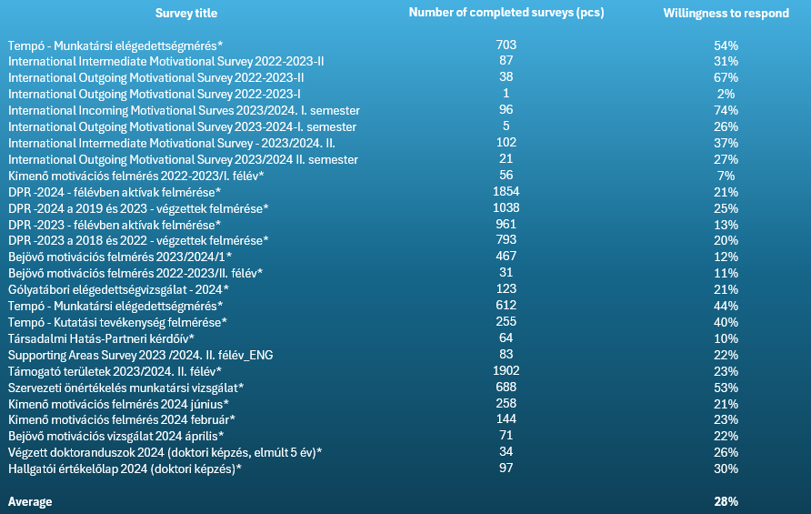

asdf

*Surveys that do not affect foreign students
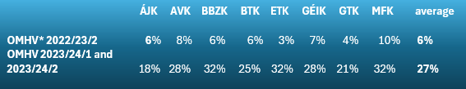

*Teacher Work Student Feedback

