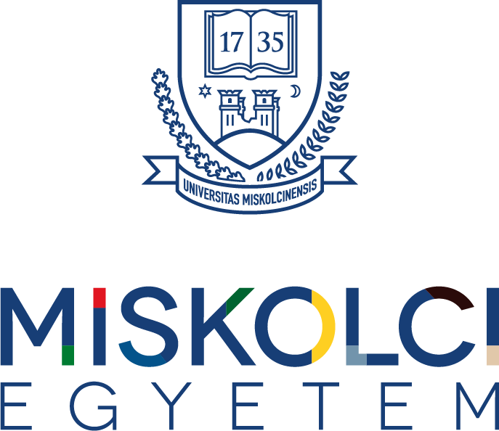

INSTITUTIONAL INFORMATION GUIDE OF THE UNIVERSITY OF MISKOLC

ACADEMIC YEAR 2026/2027

Contents
INSTITUTIONAL INFORMATION GUIDE OF THE UNIVERSITY OF MISKOLC 1
ACADEMIC YEAR 2026/2027 1
Name, address and institutional identification number of the higher education institution 1
General characteristics of the higher education institution and specific conditions of programmes funded by a Hungarian state scholarship (full or partial) 1
Specific conditions of programmes funded by a Hungarian state scholarship (full or partial) 1
Reclassification to a self-funded programme 1
Reclassification from a self-funded programme to a programme funded by a Hungarian state scholarship (full or partial) 1
Electronic access to the Student Requirements System 1
Schedule of the academic year and teaching periods, including key dates applicable to students 1
Procedure for administering students’ academic affairs and student service hours 1
Student service hours 1
How students can access counselling services 1
Life-career counselling and information services 1
Mental-health and psychological counselling services 1
Community services 1
Procedure for applying for the final examination and components of the final examination 1
Name, contact details and activities of the institutional mobility coordinator 1
Name, contact details and activities of the coordinator for students with disabilities 1
Student appeals procedure 1
Enrolment and semester registration procedure 1
Enrolment for the first semester 1
Registration for subsequent semesters 1
Deadlines, withdrawal and financial consequences 1
Specific information for international students 1
Fees and tuition fees charged by the higher education institution and general terms of agreements relating to the programmes 1
Fees for additional services 1
Payment of tuition fees 1
Payment by instalments 1
Training agreement 1
Amount and rate of tuition fees 1
Scholarships and support in self-funded programmes 1
Other fees and charges 1
Dormitory and student-residence accommodation options 1
Entry to and stay in dormitories 1
Occasional accommodation booking 1
Library and computer services 1
Library services 1
Computer services 1
Sports and recreational opportunities 1

Name, address and institutional identification number of the higher education institution

University of Miskolc
3515 Miskolc-Egyetemváros
Telephone: (46) 565-111
Website: http://www.uni-miskolc.hu
Institutional ID (OM): FI87515

General characteristics of the higher education institution and specific conditions of programmes funded by a Hungarian state scholarship (full or partial)

The historical predecessor of the University of Miskolc was the mining and metallurgy school, the Bergschule, founded by Charles III in Selmecbánya in 1735, where higher education in mining and metallurgy was launched for the first time in the world. Maria Theresa elevated the institution to the rank of an academy in 1762, and forestry education was added to the educational portfolio from 1846.

The Academy of Selmecbánya had a significant influence on the development of European technical higher education. Its teaching methods, particularly laboratory-based education, served as a model for several later European technical higher education institutions. With the participation of professors from Selmecbánya, the world’s first international technical association was also established in Szklenó, with representatives from 14 countries.

Teaching was suspended between 1848 and 1850 because of the events of the Hungarian War of Independence. Following the Austro-Hungarian Compromise of 1867, Hungarian replaced German as the language of instruction, and the institution continued to operate as the Royal Hungarian Academy of Mining and Forestry. After the Treaty of Trianon, Selmecbánya became part of Czechoslovakia, so the Academy moved to Sopron.

The establishment of the university in Miskolc was provided for by Act XXIII of 1949. On this basis, the Technical University for Heavy Industry was established in Miskolc, initially comprising the Faculty of Mining and Metallurgical Engineering relocated from Sopron and the newly founded Faculty of Mechanical Engineering. The first day of teaching was 18 September 1949. After the present site of the university had been designated, development of the University Town began, and the first teaching buildings were put into use in the autumn of 1951. At the first graduation ceremony in Miskolc in 1953, 236 students received their degrees.

In the next stage of the institution’s development, fields in the social sciences gradually appeared alongside technical programmes. Legal education began in 1981 and operated as an independent faculty from 1983. Economics education started in 1987, followed by the establishment of the Faculty of Economics in 1990. At the same time, the ambition strengthened to develop the institution into a university with a classical universitas character. The institution was renamed the University of Miskolc on 1 July 1990. The Institute of Humanities was established in 1992 and attained faculty status in 1997. Also in 1997, the Miskolc branch of the Liszt Ferenc College of Music joined the University, first operating as the Béla Bartók Institute of Music of the University of Miskolc and, from 1 August 2021, as a faculty.

The faculties operating in technical fields continue their activities in renewed organisational forms under the names Faculty of Earth and Environmental Sciences and Engineering, Faculty of Materials and Chemical Engineering, and Faculty of Mechanical Engineering and Informatics. As a result of university integration, the Comenius Teacher Training College in Sárospatak operated as a college faculty of the University of Miskolc from 1 January 2000 and left the institution on 1 July 2013. In the Institute of Health Sciences, bachelor-level health visitor training started in 2001 and physiotherapy training in 2004; the institute obtained faculty status in 2005 and is now called the Faculty of Health Sciences.

The educational structure of the University of Miskolc now covers several fields of science. The faculties and institutes cooperate to provide education, research and professional activities across the different fields of study. Students may pursue parallel studies, enrol in subjects offered by other faculties and take advantage of professional links between programmes.

Pursuant to a decision of the Government of Hungary adopted in 2020, the University of Miskolc is a state-recognised and registered higher education institution in Hungary maintained by the Universitas Miskolcinensis Foundation.

Specific conditions of programmes funded by a Hungarian state scholarship (full or partial)

Students participating in programmes funded by a Hungarian state scholarship or Hungarian state partial scholarship are governed by Act CCIV of 2011 on National Higher Education, its implementing decrees, and the Student Requirements System of the University of Miskolc. This guide provides a summary of the most important rules; in individual cases, the provisions of the legislation and university regulations in force at the relevant time shall apply.

Legal and institutional framework:
Act CCIV of 2011 on National Higher Education, in particular Sections 47–48 and 48/A–48/D; Government Decree 87/2015 (IV. 9.), Section 53 (2) b); and the Student Requirements System of the University of Miskolc, in particular the provisions on the period of state-funded studies and on reclassification between state-scholarship (full or partial) and self-funded forms of study.

In higher education, according to the form of financing, a student may be funded by a Hungarian state scholarship, a Hungarian state partial scholarship, or may be self-funded. To participate in a programme funded by a Hungarian state scholarship (full or partial), the student declares acceptance of the conditions of the programme upon enrolment or, in the case of reclassification from a self-funded programme, upon the first registration following the reclassification.

As a general rule, the period of state-funded studies may not exceed twelve semesters. If the student does not obtain the degree within the funded period applicable to the programme, or exhausts the available funded period, the student may continue the programme on a self-funded basis. Detailed rules on the funded period are contained in Section 47 of Act CCIV of 2011 on National Higher Education (Nftv.), Section 53 of Government Decree 51/2007 (III. 26.), and the Student Requirements System of the University of Miskolc.

A student funded by a Hungarian state scholarship (full or partial) is required, under the conditions laid down by law, to obtain the degree in the relevant programme within the prescribed time limit and, after completing the programme, to maintain employment in Hungary as provided by law; failure to meet the conditions may also give rise to a repayment obligation.

Reclassification to a self-funded programme

In each academic year, the higher education institution examines whether a student funded by a Hungarian state scholarship (full or partial) has met the academic requirements necessary to avoid reclassification. As a general rule, the results of the last two active semesters in which the student’s status was not suspended and which do not fall within a statutory exception must be taken into account.

Under the Student Requirements System of the University of Miskolc, a student funded by a Hungarian state scholarship (full or partial) who established student status in or after the first semester of the 2016/2017 academic year may be reclassified to a self-funded programme if, on average over the last two active semesters examined, the student does not meet the required credit threshold or does not achieve the weighted grade average specified for the relevant field of study.

Under the institutional requirement, the student concerned must complete an average of at least 15 credits over the last two active semesters examined, and at least 18 credits in the fields of law and natural sciences, and must also achieve the following weighted grade average:

 | Field of study | Weighted grade average
1 | humanities | 3,0
2 | economics | 2,75
3 | computer science | 2,75
4 | law | 3,0
5 | engineering | 2,75
6 | arts | 3,5
7 | medical and health sciences | 2,75
8 | teacher training | 3,0
9 | sports science | 3,0
10 | social sciences | 3,0
11 | natural sciences | 2,75

The weighted grade average must be calculated for each semester and the results of the two semesters examined must then be weighted by the number of credits completed in each semester. Active semesters spent on partial studies abroad with the consent of the University are treated in the reclassification review in accordance with the applicable legislation and university regulations.

A student funded by a Hungarian state scholarship (full or partial) is exempt from reclassification if the student achieves or exceeds an average credit progression of 27 credits per semester over the last two active semesters, irrespective of the weighted grade average specified for the relevant field of study.

For the purpose of the reclassification decision, students who have studied for no more than one teaching period shall not be taken into account, nor shall students for whom failure to complete a semester is attributable to a special circumstance that may be considered or disregarded under Act CCIV of 2011 on National Higher Education or the Student Requirements System. The Student Requirements System of the University of Miskolc sets out the cases of exemption and equitable consideration and the manner in which they must be documented.

A decision on reclassification must be made at the end of the academic year, after the teaching period has been closed, but no later than 31 July.

Reclassification from a self-funded programme to a programme funded by a Hungarian state scholarship (full or partial)

If a place funded by a Hungarian state scholarship (full or partial) becomes available, a student studying in the same programme on a self-funded basis may be reclassified to that place upon application. The University decides on reclassification on the basis of the academic performance of the applicants.

An application for reclassification from a self-funded programme to a programme funded by a Hungarian state scholarship (full or partial) must be submitted electronically in the manner specified by the University no later than the last day of the third week following the close of the semester. The ranking criteria laid down in the Student Requirements System must be applied when the decision is made. The financial status of a student reclassified to a state-scholarship programme may be changed in the academic administration system only after the declaration required by law has been made.

Detailed procedural, ranking, exemption and equitable-consideration rules are contained in the Student Requirements System of the University of Miskolc.

Electronic access to the Student Requirements System

https://www.uni-miskolc.hu/wp-content/uploads/2025/04/HKR_20250501-tol.pdf

Schedule of the academic year and teaching periods, including key dates applicable to students

Planned dates for Semester I of the 2026/2027 academic year
21–26 August 2026 (Friday–Wednesday) | Freshers’ Camp “bALEKHÉT”
31 August – 5 September 2026 (Monday–Saturday) | Registration week
31 August – 5 September 2026 (Monday–Saturday) | ÁJK Neptun opens | Monday, 31 August, 08:00
31 August – 5 September 2026 (Monday–Saturday) | GÉIK full-time, except senior BSc students – Neptun opens | Monday, 31 August, 13:00
31 August – 5 September 2026 (Monday–Saturday) | GÉIK part-time – Neptun opens | Monday, 31 August, 16:00
31 August – 5 September 2026 (Monday–Saturday) | MFK Neptun opens | Tuesday, 1 September, 08:00
31 August – 5 September 2026 (Monday–Saturday) | AVK Neptun opens | Tuesday, 1 September, 10:00
31 August – 5 September 2026 (Monday–Saturday) | GÉIK senior BSc full-time students – Neptun opens | Tuesday, 1 September, 13:00
31 August – 5 September 2026 (Monday–Saturday) | BBZK, ETK – Neptun opens | Tuesday, 1 September, 15:00
31 August – 5 September 2026 (Monday–Saturday) | BTK Neptun opens | Wednesday, 2 September, 08:00
31 August – 5 September 2026 (Monday–Saturday) | GTK Neptun opens | Wednesday, 2 September, 13:00
2–3 September 2026 (Wednesday–Thursday), 09:00–12:00 and 13:00–15:00 on both days | Dormitory residents move into Buildings E/1, E/2, E/3, E/4, E/5 and E/6 of the Bolyai Dormitory
2–3 September 2026 (Wednesday–Thursday), 09:00–12:00 and 13:00–15:00 on both days | Dormitory residents move into the Uni-Hostel Student Residence
2 September 2026 (Wednesday) | Intro Day
3–5 September 2026 (Thursday–Saturday) | Freshmen’s Camp (Freshers’ Camp for international students)
4 September 2026 (Friday), 10:00 | Ceremonial Senate Meeting – presentation of honours
7 September 2026 (Monday), 10:30 | Ceremonial Senate Meeting opening the academic year
7 September 2026 (Monday) – 11 December 2026 (Friday) | Teaching period (14 weeks)
8 September 2026 (Tuesday) | Orientation Day
23 September 2026 (Wednesday) | University Sports Day  - no classes
25 September 2026 (Friday) | Researchers’ Morning  - classes are held
25 September 2026 (Friday) | Researchers’ Night  - classes are held
October 2026 (“exact date to be announced”) | Welcome Day
22 October 2026 (Thursday) | University Commemoration (Anniversary of the 1956 Revolution)  - classes are held
23 October 2026 (Friday) | Public holiday (Anniversary of the 1956 Revolution)  - no work and no classes
28–30 October 2026 (Wednesday–Friday) | Rector’s holiday
November 2026 (“exact date to be announced”) | Freshers’ Ball  - classes are held
3–4 December 2026 (Thursday–Friday) | Open Days at the University of Miskolc
7–12 December 2026 (Monday–Saturday) | Pre-examination period (1 week)
12 December 2026 (Saturday) | Working day (no classes for either full-time or part-time students)
14 December 2026 (Monday) – 23 December 2026 (Wednesday) | Examination period
24 December 2026 (Thursday) – 3 January 2027 (Sunday) | Winter break
4 January 2027 (Monday) – 30 January 2027 (Saturday) | Examination period
28 January 2027 (Thursday) – 29 January 2027 (Friday) | Graduation Senate Meetings

Procedure for administering students’ academic affairs and student service hours
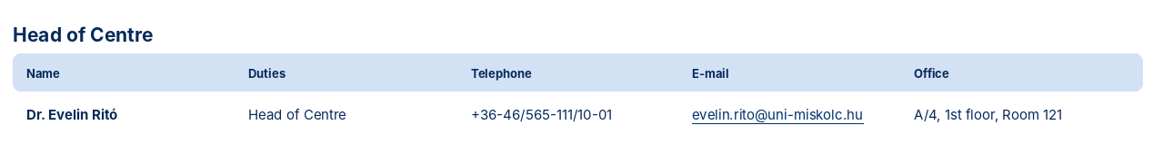
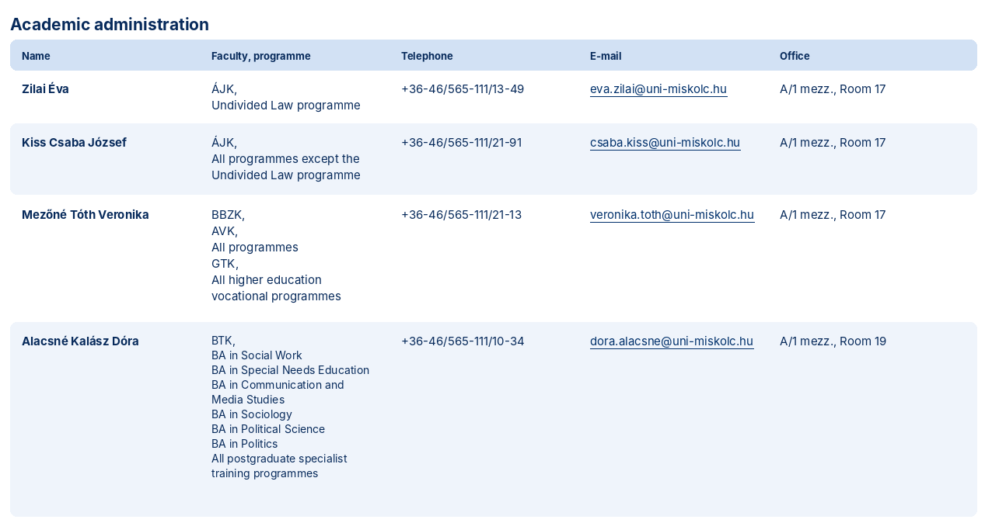

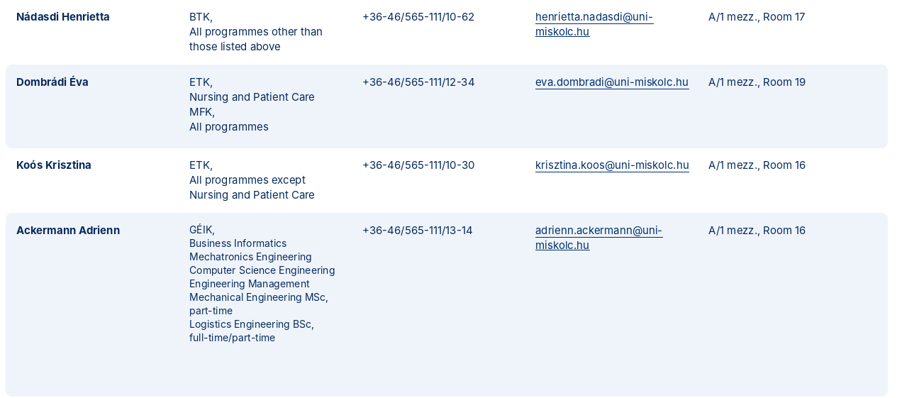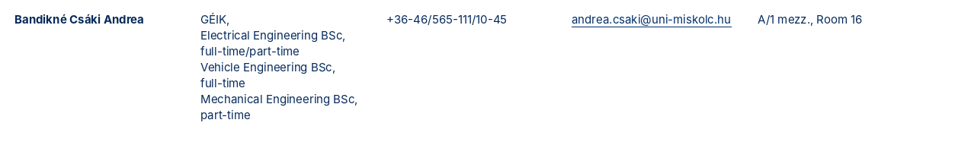
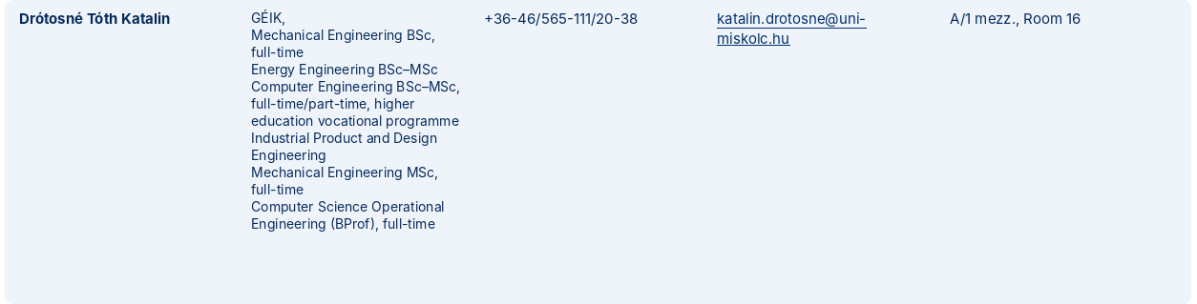
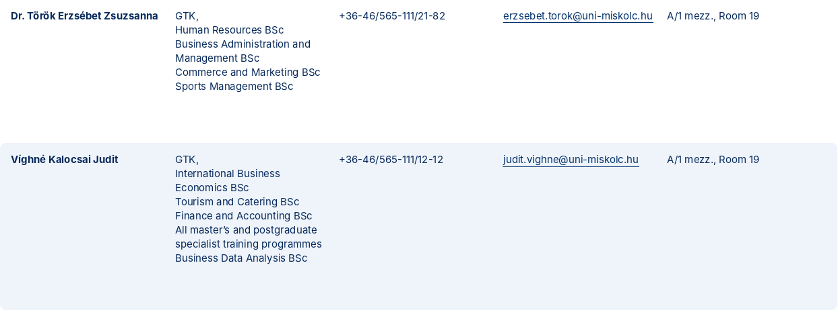

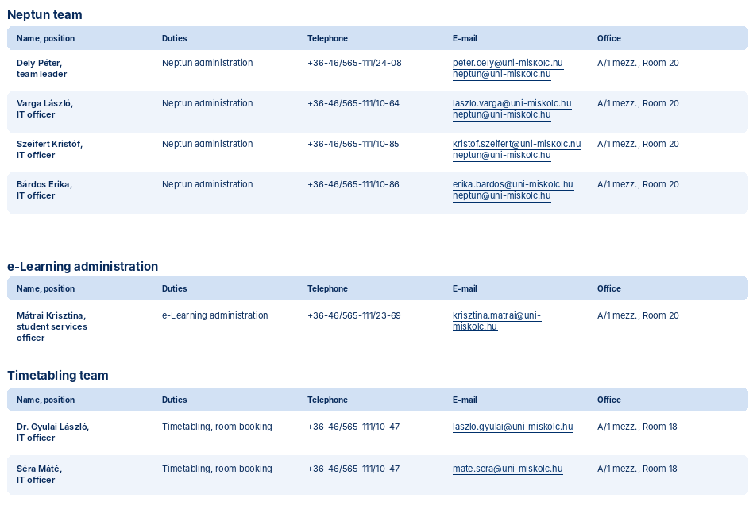

Student service hours

Academic administration:
Location: Building A/1, mezzanine, rooms 16–19 and 22.
Hours:
During the teaching period:
Monday: 9:00 – 11:00
Tuesday: 13:00 – 15:00
Wednesday: 9:00 – 11:00
Thursday: 13:00 – 15:00
Friday: 9:00 – 11:00

Academic administration for off-campus programmes:
Location | Administrators | E-mail | Planned student service hours
Ózd | Kiss Csaba József | hkozd@uni-miskolc.hu | Tue: 11:00–13:00  Fri: 13:00–15:00
Sátoraljaújhely | Ackermann Adrienn | hksujh@uni-miskolc.hu | Tue: 11:00–13:00  Fri: 13:00–15:00
Sátoraljaújhely | Kánya Tamás | hksujh@uni-miskolc.hu | Tue: 11:00–13:00  Fri: 13:00–15:00

The purpose of the Academic Affairs Group of the Centre for Educational Strategy is to administer student-related matters to the highest possible standard, facilitate access to high-quality education, and provide students with information.
Working in close cooperation with faculty dean’s offices, the Academic Affairs Group of the Centre for Educational Strategy is responsible for academic administration.

Centre for Educational Strategy  Academic Affairs Group | Dean’s Office, departmental administration
Administration related to student ID cards and student-loan applications  Scholarships and support  Academic information  Registration  State scholarship, training agreement  Issuance of certificates  Pre-degree certificate (absolutorium)  Degree certificate, diploma supplement, grade book  Other matters:  - Administration concerning international students  - Financial administration  - Timetable | Timetable and academic-schedule information  Subject enrolment  Tuition fees and debts  Processing applications  Internship and specialisation selection  Thesis and final examination  Examinations

How students can access counselling services

To help students realise their abilities, pursue their studies successfully, prepare for their professional careers, and protect their health and mental well-being, the University provides academic, life-career, career, psychological and mental-health counselling services.
Academic counselling is provided primarily by the academic administrators of the Academic Affairs Group of the Centre for Educational Strategy, academic staff, and the dean’s offices and departmental administrations of the faculties concerned. In addition to regular faculty-level information sessions, counselling on academic matters is primarily the responsibility of the Academic Affairs Group. During student service hours, administrators assist students in person and through the University’s official electronic administration and communication channels in handling academic and other student matters. Academic staff are available primarily during their office hours and through official communication channels linked to their courses. In addition to personal counselling, students are informed through information published on the University website, messages sent through Neptun, faculty information materials, and public-interest information published on the official communication channels of the University of Miskolc Student Union (ME-HÖK).

Life-career counselling and information services
The life-career and career counselling services coordinated by the Integrated Relationship Development Centre and the Career Orientation and Admissions Centre are intended to support students in their academic progress, career planning, understanding labour-market opportunities, and consciously shaping their professional careers. These services include, in particular, academic and career counselling, communication of labour-market needs and career opportunities, information on university career and career-orientation programmes, and the organisation of the annual Career Fair and its accompanying events.

Mental-health and psychological counselling services
Psychological and mental-health counselling services support students in addressing problems related to studying, life management, communication, conflict management, self-awareness, performance anxiety, crisis situations, career planning, and personal or relationship difficulties. The services are available from designated professionals by prior appointment. The counselling services are intended to assist students who need support with academic, life-management, personal or career-choice matters, as well as those who need help entering the labour market or defining their professional goals.

Community services
The Community Service Office (KÖSZI), operating within the Career Orientation and Admissions Centre, supports members of the university community through community programmes, volunteering opportunities and student community-building activities. Its regular services include the Board Game Club, Craft Workshop, Multilingual World Café, Multilingual Uni Trip and KÖSZI Experience Days. Its activities include, in particular, organising community programmes and services, supporting student self-organised groups, coordinating school community service, and providing university-level professional coordination for the “Teach for Hungary!” mentoring scholarship programme. The office is located on the ground floor of Building C/2 (at the Tapolca-facing end of the building behind the “Jó Szerencsét!” sign) and can be found on social media under the name KÖSZI ME. Detailed contact information for counselling and community services, the names, e-mail addresses and offices of administrators and counsellors, and the rules for student service hours or appointments are provided in the related tables in this guide.

Integrated Relationship Development Centre (IKK) – staff and responsibilities:

Name | Position | Organisational unit | Telephone | E-mail | Responsibilities / area
Erdélyi-Rajhárd Bettina | Head of Centre | IKK | 10-23 | bettina.rajhard@uni-miskolc.hu | Head of Centre
Székely Barbara | Vice-Rector’s officer | IKK | 14-01 | barbara.szekely@uni-miskolc.hu | General administration (administrative tasks concerning students with disabilities)
Eszláriné Szűts Gabriella | Vice-Rector’s officer | IKK | 10-46 | gabriella.eszlarine@uni-miskolc.hu | Finance
Gréczi Edit | Psychologist | IKK | 20-90 | pszichologus@uni-miskolc.hu | Psychological services (international students)
Szabó Zita | Psychologist | IKK | 16-12 | pszichologus@uni-miskolc.hu | Psychological services
Hajdu-Husvéti Noémi | Psychologist | IKK | 20-90 | pszichologus@uni-miskolc.hu | Psychological services
Csukerda Lajos | Psychologist | IKK | 16-12 | pszichologus@uni-miskolc.hu | Psychological services and career services
Dr. Fekete Sándor | University Disability Coordinator | IKK | 20-49 | sandor.fekete@uni-miskolc.hu | Disability Coordinator
Dr. Mélypataki Gábor | Equal Opportunities Officer | ÁJK | 23-84 | gabor.melypataki@uni-miskolc.hu | Equal Opportunities Officer

Career Orientation and Admissions Centre (PFK) – staff and responsibilities:

Name | Position | Organisational unit | Telephone | E-mail | Responsibilities / area
Erdei László | Head of Centre | PFK | 14-04 | laszlo.erdei@uni-miskolc.hu | Head of Centre
Dr. Juhász Orchidea Marianna | Head of Office | PFK | 12-42 | orchidea.juhasz@uni-miskolc.hu | Community Service Office (KÖSZI)  “Teach for Hungary!” mentoring programme, volunteering programmes, community programmes
Csorba Mónika Mária | Administrator | PFK | 12-42 | monika.csorba@uni-miskolc.hu
Murvainé Ádám Anetta | Organiser, trainer | PFK | 12-42 | anetta.adam@uni-miskolc.hu
Bolyai Vivien | Intern | PFK | 12-42 | vivien.bolyai@uni-miskolc.hu
Muntyán Bernadett | Group Leader | PFK | 12-25 | bernadett.muntyan@uni-miskolc.hu | Career services

Student Services

Counselling service | Counsellor | E-mail | Office | Extension
Mental-health counselling | Gréczi Edit | pszichologus@uni-miskolc.hu | Building A/1, mezzanine, Room 33 |  | By appointment
Mental-health counselling | Szabó Zita | pszichologus@uni-miskolc.hu | Building A/1, mezzanine, Room 34 |  | By appointment
Mental-health counselling | Hajdu-Husvéti Noémi | pszichologus@uni-miskolc.hu | Building A/1, mezzanine, Room 33 |  | By appointment
Mental-health counselling | Csukerda Lajos | pszichologus@uni-miskolc.hu | Building A/1, mezzanine, Room 34 |  | By appointment
Life-career and career counselling | Muntyán Bernadett | bernadett.muntyan@uni-miskolc.hu |  |  | By appointment
Life-career and career counselling | Csukerda Lajos | pszichologus@uni-miskolc.hu | Building A/1, mezzanine, Room 34 |  | By appointment
Counselling on studies and applications | ME-HÖK officers | hok-elnok@uni-miskolc.hu | Building A/1, 1st floor, Rooms 125–126 |  | By appointment

Academic and information services | Administrator | E-mail | Office | Extension | Student service hours
Information on application opportunities, scholarships and University events | ME-HÖK officers | hok-elnok@uni-miskolc.hu | Building A/1, 1st floor, Rooms 125–126 |  | by prior appointment*
Peer support provided by students on regulations and academic matters

*Appointments with ME-HÖK officers concerning application opportunities and scholarships are available by prior arrangement at hok-elnok@uni-miskolc.hu or through the MEapp application.

Other services | Administrator | E-mail | Office | Extension | Hours
Community services and volunteering programmes | Csorba Mónika Mária | monika.csorba@uni-miskolc.hu | Building C/2 | 12-42 | Mon–Thu 08:00–16:00,  Fri 08:00–13:00
“Teach for Hungary!” Mentoring Programme
Community programmes and games

Procedure for applying for the final examination and components of the final examination

The final examination is an assessment linked to obtaining the degree and completing the programme. Its purpose is to verify and evaluate whether the student possesses the knowledge, skills and abilities required for the qualification concerned and is able to apply the knowledge acquired during the programme.
The basic rules governing the final examination, the pre-degree certificate, the issuance of the degree certificate and completion of the final examination are laid down in Act CCIV of 2011 on National Higher Education, in particular Section 50, and in the provisions and faculty supplements of the Student Requirements System of the University of Miskolc concerning final examinations. Pursuant to Section 53 (2) f) of Government Decree 87/2015 (IV. 9.), the institutional information guide must describe the procedure for applying for the final examination and its components.
Admission to the final examination is conditional on obtaining the pre-degree certificate (absolutorium) and meeting any additional requirements specified in the curriculum, recommended curriculum or faculty regulations of the programme concerned. When determining eligibility for the final examination, the competent faculty organisational unit and the university unit responsible for academic administration verify compliance with the required academic, administrative and financial conditions. A student who has failed to settle a due payment obligation owed to the University may not be admitted to the final examination.
The method and deadline for applying for the final examination, the possibility of withdrawing or amending the application, and the required documents are determined by the final-examination information of the faculty or programme concerned. As a general rule, applications are submitted in the electronic academic administration system designated by the University or in accordance with the procedure published by the faculty.
The final examination may be taken during the final-examination period specified in the academic calendar. The faculty concerned provides information on the exact date and venue of the final examination, the composition and schedule of the Final Examination Committee, and the detailed procedure for conducting the examination. The faculty must publish the students’ final-examination schedule.
The final examination may be organised in several forms. The type used is determined by the recommended curriculum, programme plan or supplementary faculty regulations of the programme concerned. The main forms of final examination may include, in particular, the following:
Main types of final examination:
a) separately from defending the thesis/diploma work, the student takes a final examination before one or more Final Examination Committees in the subjects prescribed by the curriculum;
b) the student defends the diploma work or thesis before the Final Examination Committee and takes a final examination in the subjects prescribed by the curriculum;
c) the student defends the thesis/diploma work before the Final Examination Committee and answers questions from the disciplines and specified topics related to the thesis or diploma work;
d) the student takes a written final examination, then defends the thesis or diploma work before the Final Examination Committee, and subsequently takes practical and theoretical (oral) final examinations. e) the student defends the thesis or diploma work before the Final Examination Committee and then takes written, practical and theoretical (oral) final examinations. The final examination must include an oral component in whole or in part, may consist of several parts, and may also include a practical examination component. No credit value may be assigned to the final examination.
Where a final examination consists of several parts, the Student Requirements System and the supplementary rules of the faculty concerned govern the preparation time between examination parts, the order of the individual parts, and the possibility of repeating or improving them. In the case of a single-part complex final examination, the rules on providing preparation time are likewise contained in the institutional and faculty provisions.
Assessment of the thesis or diploma work may be a condition for admission to, or commencement of, the final examination. If defence of the thesis or diploma work forms part of the final examination, the student may begin the other parts of the final examination in accordance with the rules applicable to the programme and type of final examination concerned.
The competent faculty, institute or department must publish in advance for students the requirements of the final examination, the examinable topics and their subject matter, and the recommended or compulsory literature. Detailed requirements and deadlines are contained in the faculty information, recommended curriculum, thesis/diploma-work guide and final-examination information applicable to the programme concerned.
The possibility of taking the final examination after termination of student status, the applicable time limits, and any conditions that may be imposed are governed by the Act on National Higher Education and the Student Requirements System of the University of Miskolc.

Name, contact details and activities of the institutional mobility coordinator

Szőke Krisztina, Erasmus officer, mobility coordinator
Internationalisation Centre, Building A/4, 1st floor, Room 113
Tel.: (46) 565-111, extension 20-55
E-mail: krisztina.szoke@uni-miskolc.hu
The Directorate staff are pleased to provide information on European mobility programmes coordinated by the University (ERASMUS+, CEEPUS, CAMPUS MUNDI), as well as general rules for travel abroad and financial conditions. Other incoming application opportunities are published on the University website. Be sure to attend events (Freshers’ Camp, Open Day, Career Fair, MEN) where the ESN/Erasmus stand is present; there you can obtain information on study and traineeship opportunities abroad and on the conditions and procedure for applying.

Name, contact details and activities of the coordinator for students with disabilities

Dr Sándor Fekete, University Disability Coordinator
Integrated Relationship Development Centre,
Tel.: (46) 565-111, extension 20-49
E-mail: sandor.fekete@uni-miskolc.hu
For the equal-opportunity conditions required for students with disabilities (mobility impairment, hearing impairment, visual impairment, speech impairment, dyslexia, dysgraphia, dyscalculia) to pursue their studies, see the University of Miskolc Regulation on Mandatory Preferential Treatment for Students with Disabilities (https://www.uni-miskolc.hu/wp-content/uploads/2024/09/1_3_13_A_Miskolci_Egyetemen_fogyatekosaggal_elo_hallgatok_elonyben_reszesitesi_szabalyzat.pdf).
The Equal Opportunities Plan of the University of Miskolc is available on the University website: https://www.uni-miskolc.hu/wp-content/uploads/2024/02/ME-Eselyegyenlosegi-terv.pdf

Student appeals procedure

A student may submit an appeal against a decision or measure of the University of Miskolc connected with the student’s status, or against a failure to take a decision or measure. As a general rule, the appeal may be submitted within fifteen days from notification of the decision or, if there was no notification, from the date on which the student became aware of it.

The general rules on student appeals are set out in Sections 57–58 of Act CCIV of 2011 on National Higher Education; the mandatory content of the institutional information guide is prescribed by Section 53 of Government Decree 87/2015 (IV. 9.); and the detailed university procedural rules are contained in the Student Requirements System of the University of Miskolc.

An appeal may be submitted in particular where, in the student’s view, a decision, measure or omission of the University infringes legislation, university regulations or a provision governing student status.

As a general rule, no appeal lies against a decision concerning the assessment of studies. Exceptionally, however, an appeal may also be submitted against such a decision if the student considers that the assessment was not based on requirements previously adopted and published by the University, was contrary to University regulations, or the rules governing the organisation and conduct of the examination were infringed. No appeal lies against a decision made in the exercise of equitable discretion.

The appeal must be addressed to the Student Appeals Committee but, as a general rule, submitted to the organisational unit that made the first-instance decision. The body that made the first-instance decision forwards the application, together with the case file and, where necessary, its own position, to the body competent to decide the appeal.

The Student Appeals Committee of the University of Miskolc is competent to decide student appeals. The composition of the Committee and the detailed rules governing its operation are laid down in the Student Requirements System. The chair of the Committee is the head of the Centre for Educational Strategy; its members include an academic representative of the faculty concerned and a representative delegated by the University of Miskolc Student Union, or, in matters concerning doctoral students, by the University of Miskolc Doctoral Student Union. In dormitory matters, the dormitory representative specified in University regulations participates in the procedure.

A person may not participate in the appeal procedure if an objective assessment of the matter cannot be expected from that person or if a ground for exclusion specified in the Student Requirements System or Act CCIV of 2011 on National Higher Education applies.

As a general rule, the Committee decides an appeal within thirty days of receiving it. The Committee decides on the basis of the case file, but may, where justified, initiate a personal hearing of the student. The student may submit written comments and supplements and may also act through an authorised representative in the procedure.

As a result of the appeal procedure, the Committee may reject the application, amend or annul the first-instance decision, or, where necessary, order the body that made the first-instance decision to conduct a new procedure. The decision made in the appeal procedure must be communicated to the student.

A decision made in the appeal procedure becomes final upon communication. The student may seek judicial review within thirty days of communication on the grounds of an infringement of law or of a provision governing student status. Detailed rules on judicial review are contained in Act CCIV of 2011 on National Higher Education, the Act on the Code of Administrative Court Procedure, and the Student Requirements System.

A student may initiate proceedings before the Commissioner for Educational Rights once the student has exhausted the institutional appeal remedies, with the exception of court proceedings.

Enrolment and semester registration procedure

Only an enrolled student may pursue studies at the University of Miskolc. Enrolment takes place when student status is established, at the commencement of studies. Thereafter, before the start of each academic semester, the student must register for that semester or declare the suspension of studies.

The basic rules governing the establishment of student status, enrolment, semester registration, active and passive semesters, and the maintenance of student records are contained in Act CCIV of 2011 on National Higher Education, its implementing decrees, and the Student Requirements System of the University of Miskolc.

The student is responsible for ensuring that the personal data recorded in Neptun are up to date. Changes in personal data must be reported without delay, and data that the student is authorised to modify must be updated by the student. The consequences of failing to report a change in data are borne by the student. If the University is informed of a change in a student’s personal data from an authentic public register, it updates the data ex officio and informs the student electronically through Neptun.

Enrolment for the first semester
At the commencement of studies, enrolment and registration for the first semester are conditional on verification of personal data, provision of the documents specified in the enrolment notice, and complete submission of the documents specified in the admission notice by completing the electronic data-verification form.
For a student funded by a Hungarian state scholarship or Hungarian state partial scholarship, enrolment is conditional on signing the declaration accepting the conditions specified in Act CCIV of 2011 on National Higher Education. For a student in a self-funded programme, enrolment is conditional on signing the student training agreement.
If documents or information are incomplete, the Centre for Educational Strategy provides the student with an opportunity to remedy the deficiency. Failure to remedy the deficiency may result in restrictions on examination registration.

Registration for subsequent semesters
Registration for subsequent semesters is conditional on the student having fulfilled the academic obligations of the previous semester according to Neptun records and having settled any overdue debt owed to the University on any legal ground.
For students who established student status from the first semester of the 2014/2015 academic year onwards, an additional condition of registration is payment of the administration fee through Neptun. An exception may apply where the student pays the tuition fee through the Student Loan scheme or, upon request, in one lump sum—typically because a single invoice is to be issued to the employer.
The student must register electronically in Neptun for the relevant semester during the period prescribed for the student, but no later than registration week, and must enrol in at least one subject. A semester qualifies as an active semester if the student has completed electronic registration and enrolled in at least one subject.

Deadlines, withdrawal and financial consequences
A student may request an extension of the enrolment or semester-registration deadline in advance where justified. If prevented from meeting the deadline, the student may subsequently justify the omission within fifteen days from the start of the teaching period. No justification may be submitted after this deadline.
A student may withdraw semester registration in writing within 30 days after the start of the teaching period. The semester qualifies as active even if, after registering, the student does not attend classes, sit examinations, or complete any curricular academic requirement. If enrolment or semester registration is withdrawn, the administration fee is not refundable.
In a self-funded programme, the full tuition fee may be charged if the student duly enrolled or registered for the semester and enrolled in subjects. This applies regardless of whether the student actually attended classes, sat examinations or fulfilled any academic obligation.
The University of Miskolc does not limit the number of active semesters available to self-funded students until they obtain the pre-degree certificate (absolutorium). Maintaining records of student status and other records connected with student status, and issuing certificates, fall within the competence of the Centre for Educational Strategy.

Specific information for international students

Information for international students is available on the English-language website of the University of Miskolc: https://www.uni-miskolc.hu/en

Fees and tuition fees charged by the higher education institution and general terms of agreements relating to the programmes

Students are required to pay the fees and charges connected with student status. As a general rule, payment obligations must be fulfilled through Neptun; for occasional payments, a cash-transfer order made available for this purpose may exceptionally be used.

Legal and institutional framework:
Fees and charges payable by students, tuition fees, the training agreement, and the consequences of failing to meet payment obligations are governed by Act CCIV of 2011 on National Higher Education, its implementing decrees, and the Student Requirements System and related institutional regulations of the University of Miskolc.
The student must ensure that sufficient funds are available for fees and charges posted in Neptun and must meet payment obligations by the relevant deadlines. Overdue debt may restrict the exercise of certain rights connected with student status. A student who has not settled a due payment obligation owed to the University may not be admitted to an examination or final examination.

Fees for additional services
A student participating in a programme funded by a Hungarian state scholarship or Hungarian state partial scholarship may also be required to pay a fee if the student takes additional credit-bearing training beyond the level the University of Miskolc is required to provide. The detailed procedure for determining such fees is laid down in faculty regulations.
No fee is payable for courses classified by the Rector as being of strategically important University interest.

Payment of tuition fees
Students who are not funded by a Hungarian state scholarship or Hungarian state partial scholarship pay tuition fees. As a general rule, the tuition fee must be paid in one lump sum by the deadline specified by the University after it has been posted in Neptun.
A student in a self-funded programme must pay an administration fee each semester in the amount of HUF 50,000. Enrolment or semester registration may be completed after the administration fee has been paid through Neptun. The administration fee is credited towards the tuition fee.
Students who established student status before the first semester of the 2014/2015 academic year are not required to pay the administration fee; in their case, the full tuition fee is posted in Neptun as a single amount.

Payment by instalments
A student may apply to pay the tuition fee in instalments. The application must be submitted no later than 15 days after the end of registration week. The deadline is forfeiting; no request for excuse may be submitted if it is missed.
The dean of the faculty concerned decides on applications for payment by instalments. The dean may authorise payment in no more than two instalments. If authorised, the deadline for payment of the first instalment—50% of the tuition fee—is 15 October in the autumn semester and 15 March in the spring semester. The deadline for payment of the second instalment—the remaining 50% of the tuition fee—is 10 November in the autumn semester and 10 April in the spring semester.
Where justified, the dean may grant a deferral for payment of the first instalment. If a student granted payment by instalments does not pay the full tuition fee by 30 November in the autumn semester or by 30 April in the spring semester, the student may not sit an examination until the payment obligation has been fulfilled.
Faculties may establish stricter rules than those above for instalment-payment arrangements applicable to graduating students.
A decision on an instalment-payment arrangement is considered a decision made in the exercise of equitable discretion and therefore cannot be appealed.
If the University provides an electronic application interface for requesting payment of the tuition fee in two instalments, the application must be submitted through that interface. The electronic application may be used exclusively to request instalment payment of the tuition fee; it may not be used for other fee items, in particular the administration fee.

Training agreement
A training agreement must be concluded with a student in a self-funded programme upon enrolment. The training agreement includes, in particular, the qualification or competence obtainable through the programme, the method of monitoring and assessing student performance, the place, duration and schedule of the programme, the amount of the tuition fee, the services provided in return for the tuition fee, the consequences of breach of contract, and the conditions for any refund of tuition fees already paid.
The amount of the tuition fee may not be changed unilaterally during the existence of the student status. The training agreement is signed by the student and the dean of the faculty organising the programme. In addition to the terms of the agreement, students in self-funded programmes are also subject to the provisions of the Student Requirements System in force at the relevant time.

Amount and rate of tuition fees
The amount and method of calculation of tuition fees are determined by the faculty council with due regard to the applicable legislation and the University’s Tuition Fee Calculation Regulations. The tuition fee for each programme is a specifically determined fixed amount, irrespective of the number of subjects taken by the student in the semester concerned.
During the standard duration of the programme, the student must pay 100% of the tuition fee in each semester. If the standard duration is exceeded, the rule requiring payment of 60% of the tuition fee may apply to students admitted up to and including the 2021/2022 academic year.
Students admitted from the 2022/2023 academic year onwards must pay 100% of the tuition fee in each semester during the standard duration of the programme. In the two semesters following the standard duration specified in the training and outcome requirements for the programme, they must pay 60% of the tuition fee, and thereafter 100% again, irrespective of the number and credit value of subjects taken in the semester concerned.

Scholarships and support in self-funded programmes
As a general rule, a student in a self-funded programme is not eligible for an academic scholarship or a regular social scholarship. An exception may apply to a student reclassified to a self-funded programme who began studies in a programme funded by a Hungarian state scholarship and still has unused state-funded scholarship semesters available. Fees payable for failure to fulfil academic obligations or for late performance are governed by the Student Requirements System.

Other fees and charges
A student must pay a default fee in the event of failure to fulfil, or late fulfilment of, certain obligations specified in the Student Requirements System. Fees are also payable for repeated remedial examinations and for each further examination in the same subject.
Fee items may be posted in Neptun by University employees authorised for that purpose. A student may post only those fee items that are specifically marked with an asterisk (*) in the fee table.
The other fees and charges payable by students are set out in the fee table below.

Default fees | Amount (HUF)
Failure to meet the original submission deadline for a mid-semester assignment or report* | 2.000,-
Late completion of registration (except where the student proves that the deadline could not be met for reasons beyond the student’s control) | HUF 2,500/week
Unexcused absence from an examination or final examination* | 3.500,-
Modification of the study schedule in the student information system (late addition or dropping of subjects after registration week), unless the student proves that the request is made for reasons beyond the student’s control | HUF 2,500/subject
Late submission of specialisation selection | 2.000,-
Dormitory default fees
Smoking in a prohibited area of a dormitory building | 5.000,-
Third false fire alarm caused by negligence | 5.000,-
Obstructing the effectiveness of a fire-drill exercise in a dormitory | 5.000,-
Dormitory room cleaning fee | 5.000,-
Replacement of duvet or pillow in a dormitory | 6.000,-
Failure to use a sheet, or use of University-owned bedding without a cover | 6.000,-,-
Failure to pay dormitory and service fees by the payment deadline (while student status exists, with regard to the provisions of Section 74) | HUF 1,500/month
Replacement of dormitory ID card | 1.000,-
Replacement of dormitory access card | 5.000,-
Late return of the laundry-room or study-room card at the Uni-Hotel Student Residence | 2.000,-
Fees related to subject enrolment and examinations
Second and each subsequent replacement of a signature or practical grade in the same subject during the examination period* | 2.500,-
For students subject to the former Higher Education Act (Ftv.), third and each subsequent enrolment in the same subject* | 3.500,-
For students subject to Act CCIV of 2011 on National Higher Education (Nftv.), second and each subsequent enrolment in the same subject* | 3.500,-
Third examination attempt in the same subject* | 2.000,-
Fourth examination attempt in the same subject* | 3.000,-
Fifth examination attempt in the same subject* | 4.000,-
Sixth examination attempt in the same subject* | 5.000,-
Seventh and each subsequent examination attempt in the same subject* | 6.500,-
Fee for repeated final examination* | 4.000,-
Rector’s or Dean’s equitable-discretion permission* | 4.000,-
Improvement of a successful examination or practical grade (one opportunity) | free of charge
Late-payment fees
Failure to pay the tuition fee, until examination registration is blocked | HUF 4,000/month
Administrative fees
Certificate of the pre-degree certificate (absolutorium), successful final examination, or insert for an honours degree certificate (from the second issuance) | 5.000,-
Duplicate degree certificate | 15.000,-
Replacement of a traditional paper grade book (if lost, damaged or the original is full)* | 13.000,-
Duplicate paper or electronic grade book | .13.000,-
Other certificate concerning studies (e.g. copy of student register) | HUF 2,000/page, max. HUF 13,000
Issuance of a course syllabus to persons no longer holding student status with the University | HUF 3,000/subject
Duplicate diploma supplement | 12.000,-
Domestic postage of a degree certificate by registered mail with acknowledgement of receipt | 15.000,-
Domestic postage cost for documents (except degree certificates), in addition to the administrative fee | 3.000,-
Issuance of certificates in English | HUF 1,500/page
Issuance of an electronic grade book in English | 5.000,-
Application fee for admission to postgraduate specialist training | 3.000-9.000,-
Transfer application from another institution | 10.000,-
Internal transfer application | 5.000,-

For the application of other fees and charges, the expression “enrolment in a subject” must be interpreted in accordance with the legal framework applicable to the student.

For students subject to the former Higher Education Act who established student status after 1 September 2006, enrolment in a subject means registering for the lectures, seminars, consultations, practical classes and field practices required to fulfil the educational and academic requirements specified in the programme and to obtain a certificate, degree or doctoral pre-degree certificate.

For students subject to the Act on National Higher Education who established student status after 1 September 2012, enrolment in a subject means registering for the lectures, seminars, consultations, practical classes and field practices required to fulfil the educational and academic requirements specified in the programme and to obtain a degree or doctoral pre-degree certificate.

Faculty student requirements may, in accordance with University regulations, specify additional fees and charges. The use of such fees is governed by the relevant provisions of the Student Requirements System.
As a general rule, fees must be paid through Neptun. Unless otherwise provided, the fees also apply in the following academic year. No separate decision is required concerning the payment obligation; notification of the fee item is effected by posting it in Neptun.
Faculties must make the forms required for enrolment, semester registration and submission of student applications available to students free of charge and publish them on the faculty website.
Issuance of the first degree certificate and the first diploma supplement is free of charge.
Payment of fees prescribed for students must be checked in accordance with the institutional regulations governing the management of monetary claims arising from student status.

Dormitory and student-residence accommodation options

Entry to and stay in dormitories

BOLYAI DORMITORY, BUILDINGS E/1–E/6
• resident, using the access-control system: 00:00–24:00
• visitor, using the access-control system: 06:00–23:00
• guest, with a host declaration: 23:00–06:00
• resident of another dormitory, using the access-control system: 06:00–23:00
• between dormitories, with a host declaration: 23:00–06:00
• guest, subject to limited availability and advance booking, in a guest room: 13:00–09:00

BOLYAI DORMITORY – UNI-HOSTEL STUDENT RESIDENCE
• resident, by presenting the access card: 00:00–24:00
• visitor, by depositing a student ID card or presenting an identity card: 07:00–23:00
• resident, with a host declaration: 23:00–07:00
• guest, subject to limited availability and prior registration, in a guest room: 14:00–10:30

Occasional accommodation booking
Guest rooms in the Bolyai Dormitory buildings can be booked by telephone at 46/560-250 or by e-mail at szallas@uni-miskolc.hu. Accommodation is subject to a fee.
The accommodation is located on the campus of the University of Miskolc, close to the city centre. The buildings provide high-quality services and a well-appointed hostel in the green area of Miskolc.
The University’s facilities, the technical equipment of its lecture halls, its comprehensive sports complex and its extensive accommodation capacity provide unique opportunities during the summer season, from hosting tourist groups to organising large conferences.

Library and computer services

Library services

As part of the project entitled Scientific Data Analysis Methodology Centre and Archival Open Research Data Repository, not only was a new building for the Borsod-Abaúj-Zemplén County Archives completed on the campus of the University of Miskolc, but the 50-year-old Library, Archives and Museum building was also renovated.

UNIVERSITY LIBRARY
 | Services
Upper floor of the KLM Building  Reading room  Contact  +36-46/565-320  konyvtar@uni-miskolc.hu  www.facebook.com/konlevmuz  http://www.lib.uni-miskolc.hu/  Opening hours  During the teaching period:  Monday–Friday:  08:00-20:00  Saturday:  08:00-16:00  During the examination period:  Monday–Friday:  08:00-20:00  Saturday:  08:00-16:00  July–August:  Monday–Friday: 08:00–12:00 | General services  Registration  Reservation of documents for borrowing  Photocopying  Printing  Spiral binding  Scanning  CD writing  Document lending  On-site reading  Information services (general and subject-specific)  Computer use  E-book reader lending  E-services  Access to subscribed databases  Catalogue  Interlibrary loan  Renewal  MATARKA  MIDRA administration  MTMT administration  Document preparation  Citation monitoring  Topic monitoring  Special services  European Documentation Centre  PATLIB  NAVA point  User training  Database-use training
UNIVERSITY ARCHIVES
 | Services
Location  Ground floor of the KLM Building  Contact  +36-46/565-111/16-71  leveltar@uni-miskolc.hu  http://leveltar.uni-miskolc.hu  Opening hours  Monday–Thursday  09:00-15:00  Friday  09:00-12:00 | The Archives collects, preserves and makes accessible written documents relating to the University’s history in Selmecbánya and Sopron (1735–1949) and in Miskolc (from 1949).  It also collects written records of outstanding achievements in technical higher education and industrial and engineering sciences, as well as documents concerning the lives and work of professionals who studied at the University of Miskolc and its predecessor institutions (alma mater).  The Archives provides research services, data services and information following prior enquiry and appointment.
UNIVERSITY MUSEUM
 | Services
Location  Ground floor of the KLM Building  Contact  +36-46/565-111/16-17, 16-67  muzeum@uni-miskolc.hu  Opening hours  Monday–Thursday  09:00-15:00  Friday  09:00-12:00 | The Museum’s main responsibilities are to collect, preserve, catalogue and make available for research objects and documentary materials relating to the history of the University of Miskolc and its predecessor institutions (the Mining and Forestry Academy in Selmecbánya, the College of Mining and Forestry Engineering in Sopron, and the Technical University for Heavy Industry in Miskolc), to provide continuous research and visitor services, and to organise permanent and temporary exhibitions.  The institution also considers it its mission to preserve the student traditions of Selmecbánya for future generations of students.  The University History Exhibition opens in the first week of the academic year and can thereafter be visited free of charge by prior appointment.
SELMECBÁNYA HISTORIC LIBRARY
 | Services
Location  Ground floor of the KLM Building  Contact  +36-46/565-111/16-17  muzeum@uni-miskolc.hu  Opening hours  Monday–Thursday  09:00-15:00  Friday  09:00-12:00 | The original library collection of the former mining and metallurgy alma mater in Selmecbánya, preserved intact from the period 1735–1918, is protected as a museum collection under the name Selmecbánya Historic Library. The collection of approximately 30,000 volumes contains a major selection of 16th–19th-century technical and natural-science literature and is particularly rich in 18th–19th-century technical and scientific journals.  The exhibition can be visited free of charge by prior appointment.
UNIVERSITY PRESS
 | Services
Location  Ground floor of the KLM Building  Contact  +36-46/565-111/16-82  kiado@uni-miskolc.hu  Opening hours  Monday–Thursday  07:30-16:00  Friday  07:30-13:00 | The main tasks of the University Press are the print preparation of teaching materials (lecture notes, textbooks and teaching aids), the University’s peer-reviewed journals and non-peer-reviewed volumes of University publications, scholarly works and publications written by University academic and research staff, and edited publications connected with the University’s activities, including proofreading, copy-editing, typesetting, cover design, and obtaining ISBN and ISSN numbers.
REPROGRAPHICS UNIT
 | Services
Location  Ground floor of the KLM Building  Contact  +36-46/565-111/19-66  sokikt@uni-miskolc.hu  Opening hours  Monday–Thursday  07:00-15:30  Friday  07:00-13:00 | In addition to producing University publications, teaching materials (lecture notes, textbooks and teaching aids), scholarly works and publications written by University academic and research staff, edited publications connected with University activities, administrative materials, etc., the unit also provides printing services (black-and-white and colour printing, business cards, flyers, booklets, etc.).

Computer services

The Information Technology Centre provides the basic IT infrastructure required for the operation of the University:

Internet
The University of Miskolc operates high-bandwidth gigabit internet with wired and wireless (WiFi) access, with security enhanced through access control.

WiFi
For University students, the University operates the “ME-Student” WiFi network throughout the University Town. Students can connect using their M365 e-mail address and password.
Guest visitors may use the ME-Vendeg WiFi network, which is available throughout the University campus.
Password for the ME-Vendég WiFi network: MEvendeg2023

E-mail and M365
After enrolment, the University of Miskolc automatically creates an M365 account and student e-mail address for every student with active status (based on Neptun data), and sends information about it to the non-University e-mail address recorded in Neptun. This e-mail address and the associated password provide access to M365 services, the student WiFi network (ME-Student), the University e-learning system and the Integrated Student Interface. It is important that every student have a non-University e-mail address recorded in Neptun.
M365 is a package of digital services provided by the University of Miskolc to support learning, communication and collaborative work.

M365 Office
Under the Tisztaszoftver programme, students of the University of Miskolc with active status are entitled to use the desktop version of Microsoft Office (Word, Excel, PowerPoint), which can be downloaded from https://www.office.com and activated after installation using the University e-mail address. There may be functional differences between the online and installed applications.

OneDrive
Each student’s M365 account includes 100 GB of cloud storage. Students can store files and create folders to organise their documents. The files can be accessed or shared from anywhere and from any device.

Teams
Microsoft Teams is Microsoft’s videoconferencing software and is available to students after signing in at https://www.office.com. In distance education, lectures and consultations can be conducted using Microsoft Teams. Teams is available both as an installable application and as a browser-based version. Use of the installable application is recommended.

EduID
eduID is the authentication service of KIFÜ. It allows a University of Miskolc user to sign in to a service provided by another institution via the University of Miskolc authentication (LDAP) server. eduID can also support collaborative work with international partners. An eduID account is created for every student in parallel with the M365 account, and information about it is sent to the non-University e-mail address recorded in Neptun.

EduRoam
eduRoam (education roaming) is a secure, worldwide roaming access service for the international research and education community. It allows students, academic staff and employees of participating institutions to use the registration credentials (username and password) issued by any participating institution (such as the University of Miskolc) to connect to the wireless network of another domestic or international institution belonging to the eduRoam federation. The same login credentials are used as for eduID.

VPN
A VPN, or Virtual Private Network, is an encrypted, secure channel that allows users to connect to the University network from anywhere as if they were on campus. Students of the University of Miskolc with active status may obtain VPN access upon a request submitted by an instructor through the HelpDesk. After installing and configuring the VPN client, they can connect to the University network.

Computer labs
The Information Technology Centre operates computer teaching rooms equipped with IT devices (PCs) for scheduled classes, enabling students to acquire the required knowledge and demonstrate it in examinations.

Integrated Student Interface
The Integrated Student Interface is a web application available at https://app.uni-miskolc.hu whose primary purpose is to allow students to find all materials needed for their studies in one place. Students access the web application using their M365 account and can find their enrolled courses, the related e-learning materials and the Teams group associated with each course.

Sports and recreational opportunities

One of the strengths of the University of Miskolc is its high-quality and diverse sporting life. Students choosing our institution have numerous opportunities. They may take part in sports during physical education classes, participate in various recreational-sport programmes, and train and compete regularly in an organised setting in the sections of the University sports club, the Miskolc University Athletics and Football Club (MEAFC). In keeping with its traditions, the University of Miskolc enters students every year in university competitive and recreational sports championships. Spectators are also warmly welcomed in the stands and at sports facilities throughout the year. We regularly host various domestic and international sporting events. Of particular importance, the University of Miskolc organised the World University Orienteering Championship in 2016; in 2017 at the European Universities Basketball Championship and in 2023 at the Badminton and Water Polo Championships, our University demonstrated that it is also a worthy venue for international sporting events. In 2022, our University was the first to host eight Hungarian University and College National Championships simultaneously as part of a MEFOB Festival event. In terms of participation, the 2024 European Universities Games held in Miskolc and Debrecen were of historic significance, with more than 5,000 people—athletes, accompanying persons, volunteers and organising staff—bringing the two university campuses to life for almost an entire month. In 2025, students from six universities competed in seven sports over two days as part of the Technical Higher Education Sports Days. Elite athletes are supported in their studies by a special mentoring programme. Detailed and up-to-date information on all sports services, sports programmes and sports facilities is available on the University sports portal at www.sport.uni-miskolc.hu.

Physical education: Depending on their programme, students must complete physical education for two or more semesters, with 20 sessions of physical activity required in each semester. These sessions may also be credited outside physical education classes through recreational-sport activities, repeated completion of hiking routes, or by purchasing a UNI-GYM fitness-centre pass and completing 20 visits.

The Sports Centre offers a wide range of renovated sports facilities: the University Sports Hall, the E/4 gymnasium and small hall, the Tennis Centre (4 outdoor clay courts, 4 outdoor hard courts and 4 indoor hard courts, plus 2 squash courts), 2 artificial-turf football pitches, a bitumen handball court, bitumen and synthetic-surface streetball courts, an outdoor fitness park and the multifunctional Beach Sports Centre, which also includes beach-volleyball courts.

Tennis courts: In 2024, university and Miskolc tennis life was expanded with a four-court indoor hard-surface tennis hall, four outdoor hard courts and a fully renovated and modernised clubhouse, while four clay courts remain available for players who do not prefer hard surfaces. The development also made it possible to create two squash courts in the tennis hall, available throughout the year. Further information and court booking: tenisz.uni-miskolc.hu.

Fitness centre (UNI-GYM): To purchase the discounted gym pass located on the ground floor of the Uni-Hotel and valid for an academic semester, a valid student ID or ME-CARD staff ID and a Neptun code are required. The current price is available on the Sports Centre website. Full-price monthly and seasonal passes for external users and day tickets for occasional gym use are also available.

Outdoor fitness park: The Outdoor Fitness Park next to the University Sports Hall was created so that members of the University community can try bodyweight conditioning free of charge using the installed equipment. Use is free for everyone.

Training and competition opportunities: Founded in 1951, the Miskolc University Athletics and Football Club (MEAFC) has as its primary task meeting the sporting needs of current and former students, academic staff and employees.
MEAFC provides training and competition opportunities in the following sections: table tennis, bridge, handball, football, basketball, volleyball, orienteering, tennis, badminton, cheerleading and water polo.
MEAFC seeks to ensure a high number of active University of Miskolc students among the athletes in its sections, for whom it is particularly important to emphasise the significance of a healthy lifestyle and strengthen the indisputably important social and educational role of sport. The club is also open to graduates, enabling them to maintain ties with their former institution through sport. In terms of the number of athletes and teams and their results, basketball and volleyball stand out among our sections. In these sports, in addition to first-division teams, MEAFC also covers the entire youth-development system of the city.
At the Hungarian University and College National Championships, both the basketball and volleyball teams won silver medals in the colours of the University of Miskolc.
In recent years, our football section has also brought several distinctions to our club and University; our men’s university team placed third in the 2021 Hungarian University and College National Championship. Our senior squad currently competes in the NB II futsal league.
In bridge, handball, orienteering, tennis, badminton and water polo, the association’s basic objectives have been fulfilled through amateur-level competition in university, city, county and regional championships, while management has continuously sought to increase the proportion of university students.

Recreational sport: The Sports Office working group, operating within the organisational unit of the University of Miskolc Sports Centre, organises the institution’s recreational sports. This includes regular recreational activities (“Sports Afternoons”), amateur sports competitions and championships organised according to demand (University of Miskolc Small-Sided Football Championship), and large-scale sports days (e.g. University of Miskolc Sports Day and Sports Selection Event, Freshers’ Camp Sports Day, MEN Sports Day). Sports days place strong emphasis on demonstrations of different sports, programmes promoting sport and a healthy lifestyle, and sporting contests.

Sports Afternoons: The Sports Centre and Sports Office jointly provide 14 different forms of exercise each week under the name “Sports Afternoon”, from aerobics and Thai boxing to Zumba. Current services are available to all members of the University community at three locations from Monday to Thursday between 16:00 and 22:00. Amateur in-house championships are also emphasised, where University community members who do not participate in competitive sport can test their skills in different disciplines. Each year we seek to support civil initiatives; in recent years we have organised several charity events and runs where participants could contribute to the success of a cause.
The Sports Afternoons framework also includes aerobics and football for employees, as well as hiking, where trained hike leaders help participants discover the hidden beauty of the Bükk Mountains.

Sports administration: Since 2023, the University has used the TesiApp interface, which includes all physical-education classes and organised recreational-sport activities (Sports Afternoons and hiking). This has made sports activities, registration and important related information transparent and easily accessible to all members of the University community. The system is available through a user-friendly website at www.app.uni-miskolc.hu.

Mentoring programme: A special mentoring programme is available to elite athletes studying at the University of Miskolc. Its purpose is to help them coordinate their sporting and academic commitments by providing an individualised study schedule, an academic mentor, a sports scholarship and exemption from physical education.

Contact:

University of Miskolc Sports Centre and Sports Office
registered office: 3515 Miskolc – Egyetemváros
postal address: 3515 Miskolc-Egyetemváros, Körcsarnok
telephone: 46/565-252 or 46/565-111, extension 14-56
Facebook: www.facebook.com/miskolciegyetemisport
website: www.sport.uni-miskolc.hu

Student service hours:

Monday–Thursday: 9:00–15:00
Friday: 9:00–12:00
Head of Organisational Unit: Szilárd Bene (extension: 14-44)
Head of the Sports Office: Zsófia Zsíros (extension: 13-96)

University clubs and facilities:
Gasztroműhely University Restaurant www.gasztromuhely.hu
MENTA Bar&Gastro https://www.facebook.com/mentabarandgastro
University theatre season ticket: This season, the National Theatre of Miskolc again offers a rich repertoire to all employees and residents of the Campus. Applications and registration for purchasing season tickets through the Student Services Department take place at the beginning of September.
Religious life – Ecumenical University Chaplaincy: The Chaplaincy welcomes everyone seeking spiritual refreshment. Its programmes—lectures, concerts, film clubs, excursions, self-awareness courses, worship services and community evenings—offer opportunities to deepen one’s relationship with God, others and oneself. The Chaplaincy Office also provides a space for rest, study, friendly conversation or spiritual discussion.

